**DAILY ONLINE ACTIVITIES SUMMARY**

|  |  |  |  |  |  |  |  |  |
| --- | --- | --- | --- | --- | --- | --- | --- | --- |
| Date: | 04/06/2020 | | | | | Name: | Jyothi B R | |
| Sem & Sec | IV-A | | | | | USN: | 4AL18CS030 | |
| Online Test Summary | | | | | | | | |
| Subject | | Micro-processer and Embedded system | | | | | | |
| Max. Marks | | 17 | | Score | | | 20 | |
| Certification Course Summary | | | | | | | | |
| Course | Programming Essentials in Python | | | | | | | |
| Certificate Provider | | | Cisco Virtual Academy | | Duration | | | 2.5hrs |
| Coding Challenges | | | | | | | | |
| Problem Statement: 1.write a java program to read three integer values from the keyboard and find the sum of the values. Declare a variable "sum" of type int and store the result in it.  2. Write a C++ program to find the missing number in array.   |  |  |  |  |  | | --- | --- | --- | --- | --- | | |  | | --- | |  | | 12:44 (8 hours ago) |  | https://mail.google.com/mail/u/1/images/cleardot.gif  https://mail.google.com/mail/u/1/images/cleardot.gif | | |  | | --- | | to Year@noreply.github.com, Subscribed  https://mail.google.com/mail/u/1/images/cleardot.gif | | | |   write a java program to read three integer values from the keyboard and find the sum of the values. Declare a variable "sum" of type int and store the result in it. | | | | | | | | |
| Status:Completed | | | | | | | | |
| Uploaded the report in Github | | | | | Yes | | | |
| If yes Repository name | | | | | https://github.com/alvas-education-foundation/jyothi_b_r | | | |
| Uploaded the report in slack | | | | | Yes | | | |

Online Test Details: (Attach the snapshot and briefly write the report for the same)

Certification Course Details: (Attach the snapshot and briefly write the report for the same)

Coding Challenges Details: (Attach the snapshot and briefly write the report for the same)

**ONLINE TEST DETAILS**: -

The online test was from module3. There were 20 questions which contains mcq questions and the duration were 30 minutes. The questions were optimal and easy. The score that I received was 17/20.

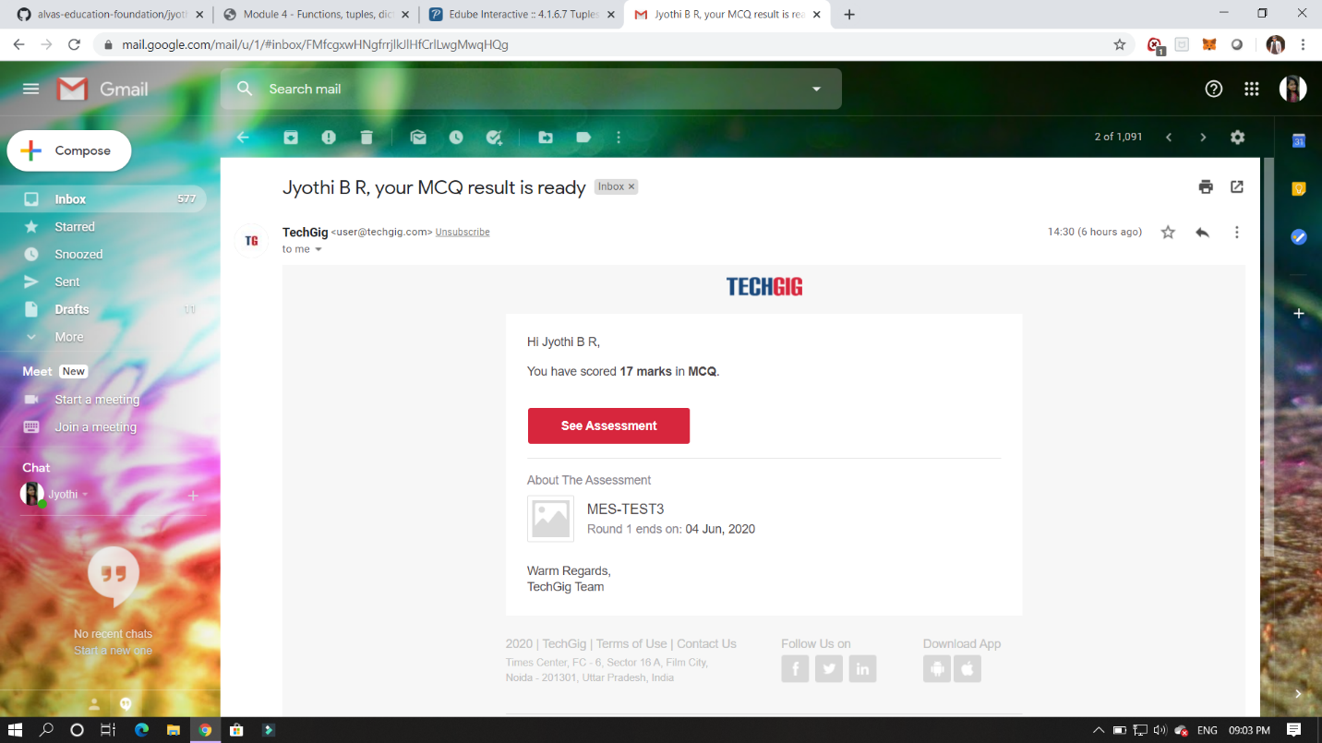

CERTIFICATION COURSE DETAILS:

Programming Essentials in Python :

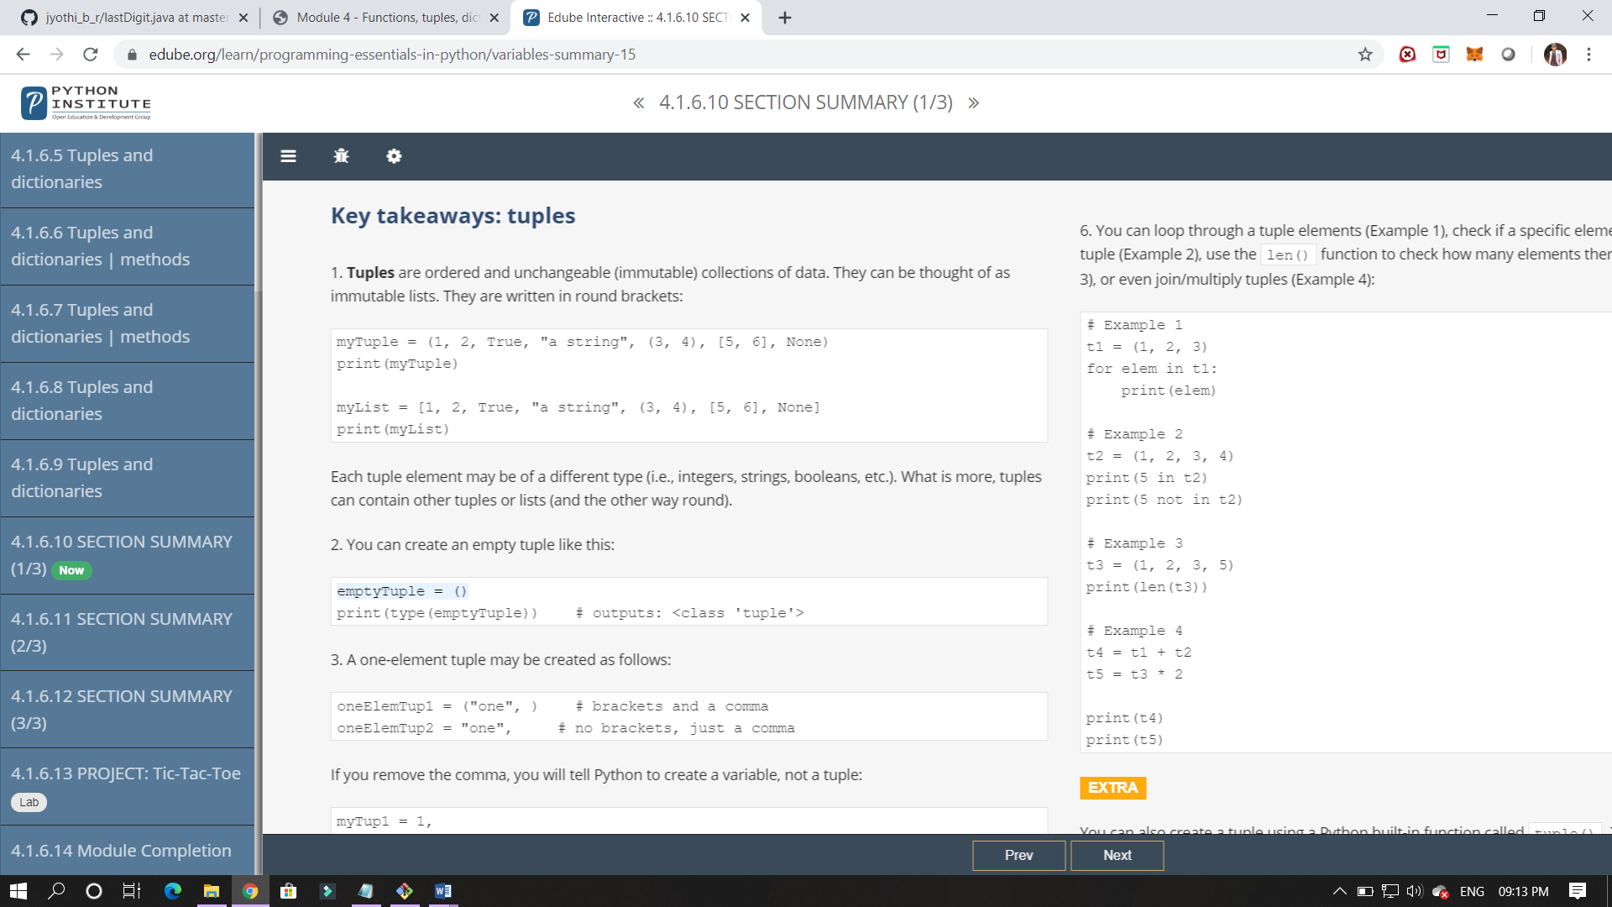

In this class I have studied about tuples and to classify it and some of its applications.

Here it is end of this module. In this module I have learned about function , parameterised function, list , tuples and dictionary . and the scope of its function where we can use it all this are studied in this module.

ONLINE CODING:

1.Given an array C of size N-1 and given that there are numbers from 1 to N with one element missing, the missing number is to be found.

**Input:**  
The first line of input contains an integer T denoting the number of test cases. For each test case first line contains N(size of array). The subsequent line contains N-1 array elements.

**Output:**  
Print the missing number in array.

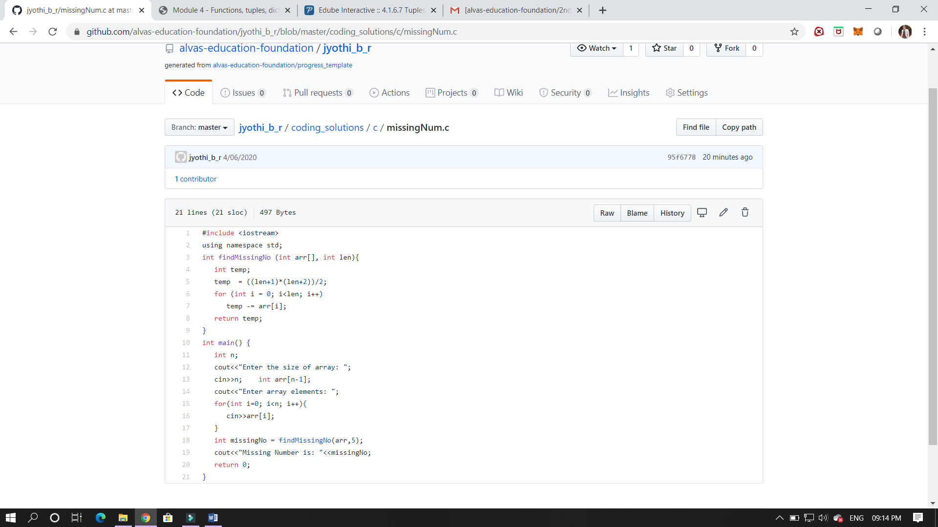

2. write a java program to read three integer values from the keyboard and find the sum of the values. Declare a variable "sum" of type int and store the result in it.

